AI ASSISTED CODING
LAB-14.5
REGURI CHAITRA REDDY
2303A51786 Batch-12
Task 1 – Image Gallery Website Create an image gallery web page.
Requirements:
- Display images in a grid layout.
- Use AI to:
o Optimize layout using CSS Grid. o Add hover zoom or overlay effects. o Ensure mobile responsiveness.
Prompt:
<!--Create a image gallery web page and make it responsive.
The gallery should display a grid of images.
Add hoverzoom and overlay effects for the images -->
Given Output:
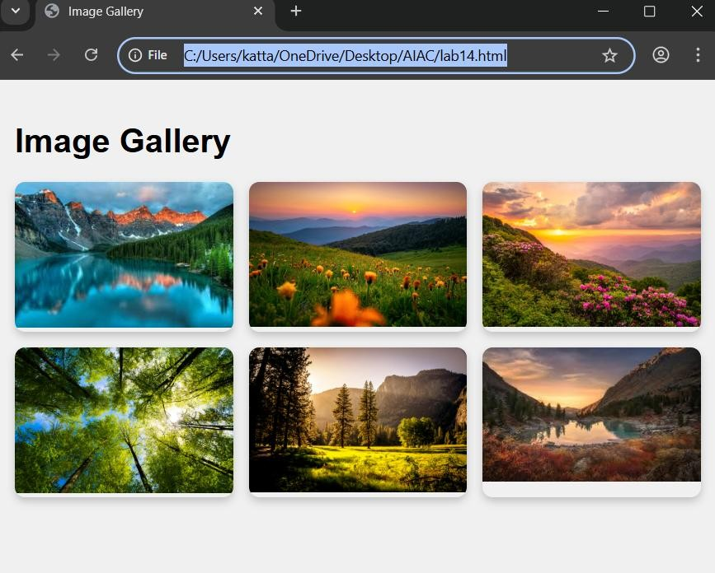

Prompt 2:
Modify the code so that when a image is clicked it should be shown full screen and when the mouse moves to an image the image should become slightly bigger.
Given Output:
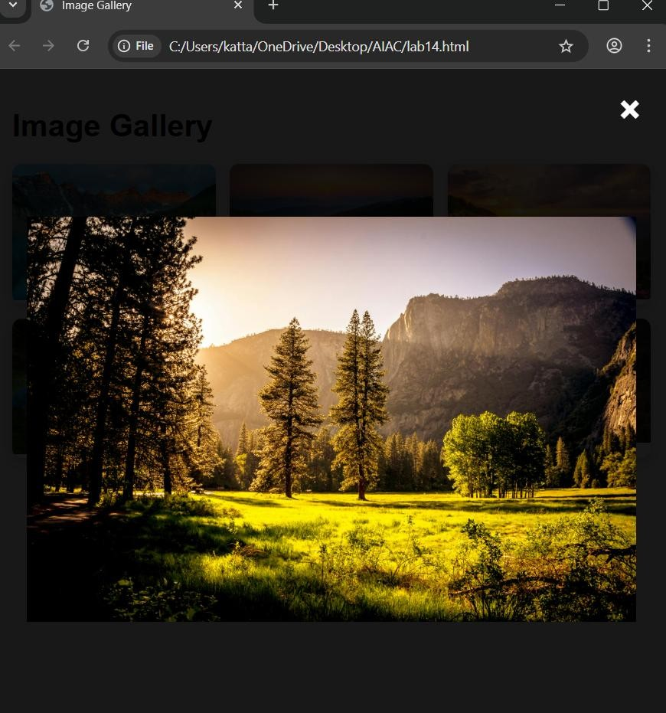

Task 2
–

Profile Card Generator

Create a profile card web page.
Requirements:
- Display user image, name, role, and social media links.
- Use AI to:
- Suggest modern UI colors and fonts. o Design the card using Flexbox.
- Add hover animation and shadow effects
PROMPT:
<!--Create a profile card web page that displays user image, name, role, and social media links.
Use modern UI colors and fonts add hover animation and shadow effects to enhance the design.
Utilize Flexbox for layout and ensure the card is responsive across different devices.--> GIVEN OUTPUT:
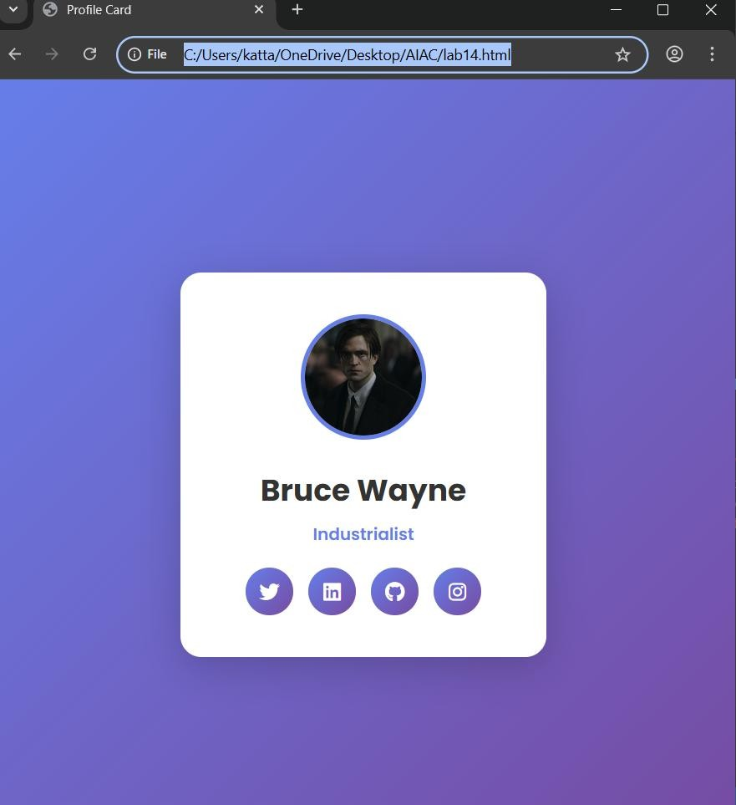

Task 3 -Develop a dynamic shopping cart system.
Requirements:
- Add, remove, and update product quantities.
- Display real-time total price.
- Use AI to:
o Manage cart state using JavaScript objects. o Persist cart data in localStorage.
PROMPT:
<!--Develop a dynamic shopping cart system which adds, removes, and updates product quantities and display real-time total price.
Use AI to manage cart state using JavaScript objects and persist cart data in localStorage.--> GIVEN OUTPUT:
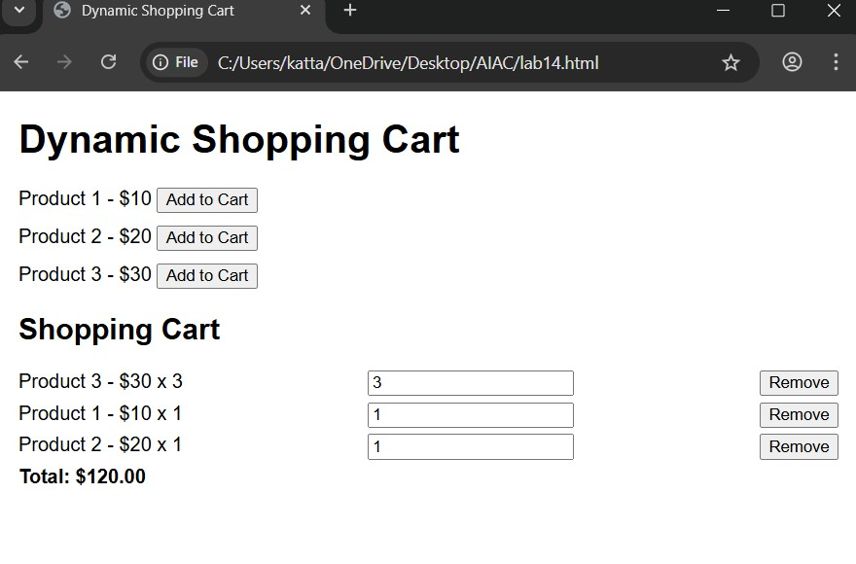
PROMPT 2:
Modify the code to make the UI more visually attractive
GIVEN OUTPUT:
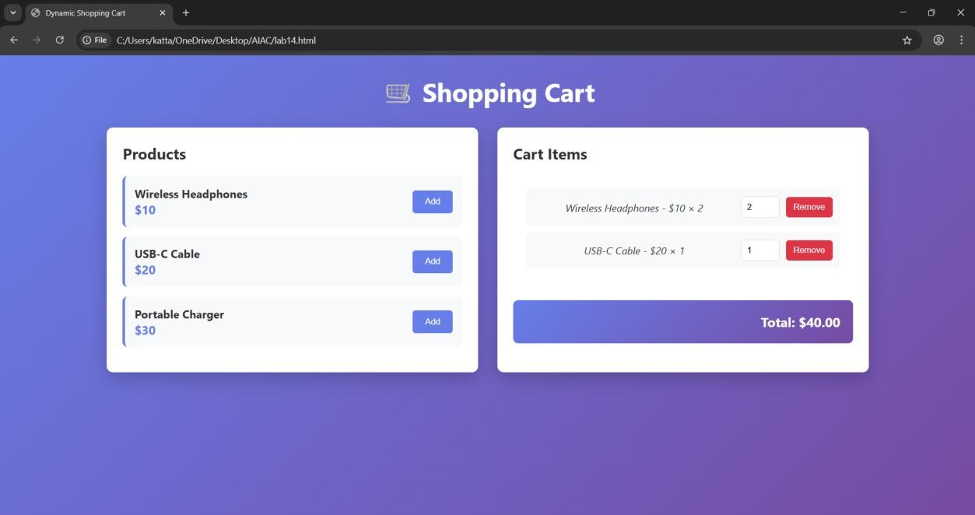

Task 4 – Role-Based Access Control Application
Create a role-based web application.
Requirements:
- Admin, Editor, User roles.
- Conditional UI rendering.
- Use AI to:
o Design access control logic. o Maintain secure state transitions. o Create scalable UI components
PROMPT:
<!--Create a Role-Based Access Control Application that has Admin, Editor, and User roles.
The application should conditionally render UI components based on the user's role.
Design access control logic. Maintain secure state transitions. Create scalable UI Components.-->
GIVEN OUTPUT:
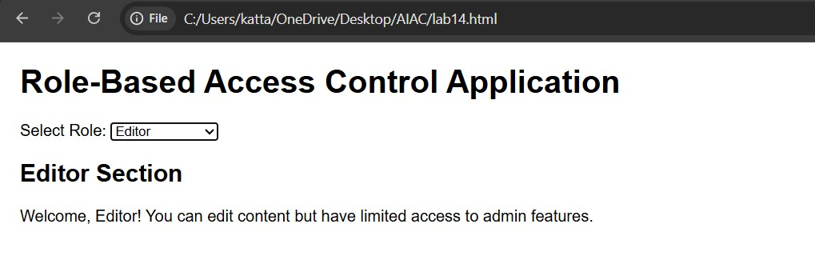

Task 5
–

Multi
-
Language Website

Design a multilingual website.
Requirements:
- Switch languages dynamically.
- Persist language preference.
- Use AI to:
o Structure translation files. o Handle RTL/LTR layouts. o Improve accessibility.
PROMPT:
<!—Create a multi-language website that switch languages dynamically, and persist language preference. Handle RTL/LTR layouts, and improve accessibility.--> GIVEN OUTPUT:
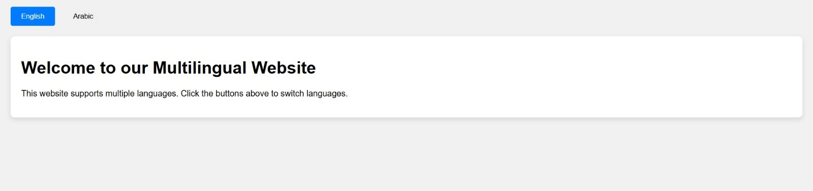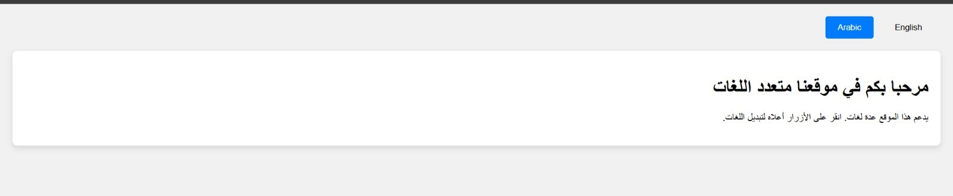
Task 6 – Online Examination System
Create an online exam interface.
Requirements:
- Timer, questions, and submission.
- Prevent multiple submissions.
- Use AI to:
o Manage exam state. o Improve exam UX. o Ensure accessibility.
PROMPT:
<!—Create an examination system which includes timer, questions, and submission and also prevents multiple submissions. Manage exam state, Improve exam UX and Ensure accessibility-->
GIVEN OUTPUT:
